Sandwatch Project in EBI Francisco Ferreira Drummond, Azores

EBI Francisco Ferreira Drummond is located in S. Sebastião, Terceira Island, in Azores, Portugal. We provide basic schooling to about 600 students, from 3 years old (pre-school education) to 15 years old (9th grade). Our school is also, since January 2015, an UNESCO Associated School – ASPNet School.
Combining our location in the middle North Atlantic and our participation in ASPNet as well as in the Azorean Eco-Schools Project, we decided to introduce the Sandwatch UNESCO project in our school as a project responding simultaneously to all the above mentioned features and school projects and objectives, like the development of civic and environmental education and protection, particularly in coastal environment, since, as you will be able to notice in the map and images bellow, in our school area we have no real sand beaches but several volcanic rocks bathing areas.
In last June, the 11th, in the end of the school year, the school undertook its first action of observation and record directed simultaneously to several natural and humanized features of selected bathing areas like Baía da Vila, Baía das Mós, also known as Baía da Mina, Baía da Salga, and 2 spots in Porto Judeu.
This educational activity aimed at recording biodiversity, human activities in the area, erosion evidences, bathing area material, pollution, buildings in the area, sea conditions and objects in the sea, according to the Sandwatch manual. The students also draw a sketch map of the area and conducted a beach clean-up. The activity involved 104 students, 10 teachers and five other staff members.
Hereafter we include a map of our coastal school area, as well as pictures of two of the groups involved in the activity.

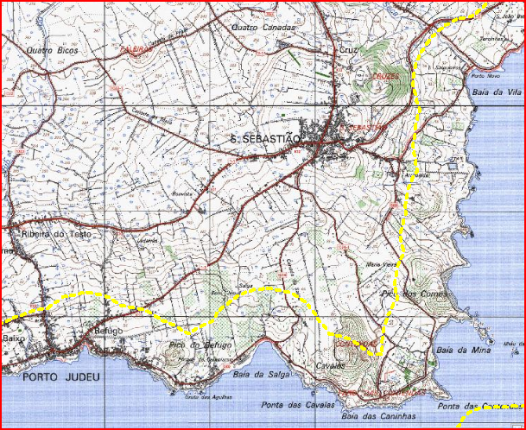
Figura 1: Mapa da zona de S. Sebastião

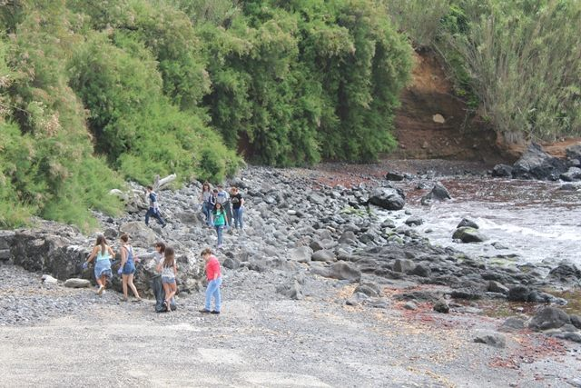
Figura 2: Ação de observação e limpeza na Zona da Baía da Vila
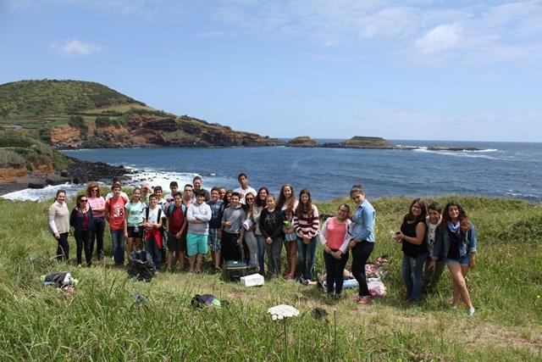
Figura 3: Ação de observação e limpeza na zona da Baía das Mós

