Implementation of Sandwatch 2020 in Mauritius

1 Introduction
In February 2020, an article was published in Sandwatch newsletter https://www.sandwatch/foundation.org/mauritius.html) providing a brief on the start of implementation of sandwatch 2020 in three schools. These were:
- Second time at France Boyer de la Giroday State Secondary School (FBGSSS) at Blue Bay Beach in the south of Mauritius
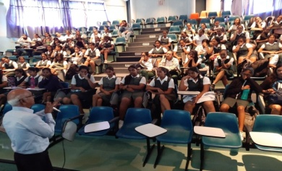
- First time at (a) Sir Leckraz Teelock SSS (SLTSSS) at the Belle Mare Beach in the east, and (b) Dr. Regis Chaperon SSS (DRCSSS) at Flic en Flac in the west.
Following meetings with the respective Rectors of the three schools, a tentative programme was prepared for the period January to July. In each school, four in-class sessions were held to introduce sandwatch and provide training in observation, measurement and analysis of beach data and in data entry in the International database. Four outdoor activities were planned to collect data on the beach representing summer and winter conditions. A closing ceremony at a venue with the presentation of results and findings from the three schools was also scheduled. The Covid-19 pandemic, however, with lockdown at the end of March disrupted the programme.

2. Activities from January to March
Activities started well at the beginning of the period. However, bad weather at the end led to cancellation of some planned activities with the result that the number of activities in the three schools was quite uneven.
2.1 France Boyer de la Giroday SSS
The first training took place on 04 February in the theatre of the school in the presence of around 100 students of Grades 10 and 12 and four educators. This provided an opportunity to elaborate on problems facing coastal resources and ecosystems in Mauritius and the link to climate change, benefitting thus a large group of students. Twenty students from Grade 12 subsequently participated actively in all future in-class sandwatch activities and the collection of beach data during outdoor sessions at the Blue Bay public beach.
The first outdoor session took place on 13 February with the participation of the 20 students and three educators. They were divided into 3 groups and each group was allocated specific tasks to collect data and gather information on various beach characteristics. The same reference objects as identified for Sandwatch 2019– southern kiosk, a wall in the middle of the beach length under study and an inclined wall at the end - were used to enable comparison. https://www.sandwatchfoundation.org/the-france-boyer-de-la-giroday-state-secondary-school.html)
The students took a laudable initiative of examining sand sample collected in the inter
tidal zone under a school microscope. It was thus possible to determine the shape, type and
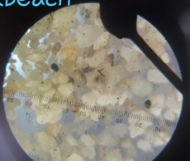
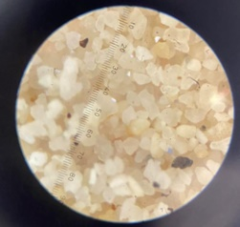
size of the sand grains.

Sand grains under a microscope
The 2nd indoor session took place on 27 February in the biological laboratory of the school. The focus was on the use of the sandwatch International database for data entry. Hands-on training on data entry was provided to familiarize the students on its use, an important component of sandwatch to archive data on a permanent basis and make it available for further reference to identify changes due to human activities and climate change impacts. The 2nd outdoor session scheduled on 18 March, however, could not take place on account of bad weather.
2.2 Sir Lechraz Teelock Secondary School SSS
The first training on sandwatch took place on 23 January in the theatre of the school. About 50 students from Grades 10 and 12 and four educators attended the session. They were encouraged by the school Rector to participate in sandwatch activities, which would help them to develop critical thinking skills and apply them to resolve conflicting issues, thus instilling a sense of caring for their beaches.
The first outdoor session was held on 06 February at Belle Mare Public beach. This beach was selected as it represents a good example of a beach facing the problem of coastal erosion and remedial measures taken have not been very effective. Reference objects from where all measurements would be taken were first identified. These are (i) the left wall of the South African Airways memorial erected in memory of the 159 passengers and crew who lost their lives in a crash on November 28 1987 just off Belle Mare and (ii) the lowest step of a stepping access.
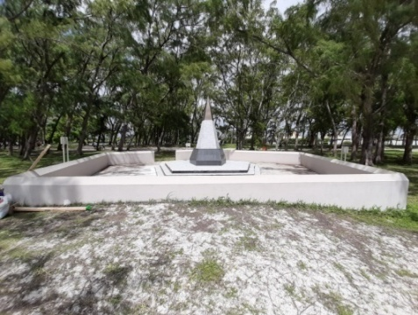
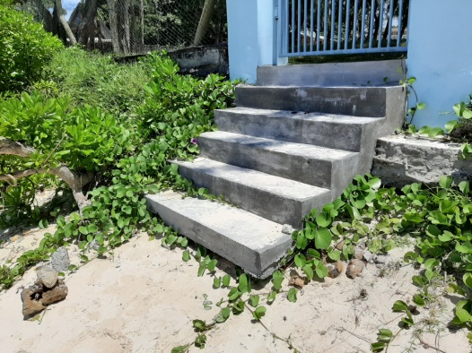
Observations and measurements were made during two outdoor sessions representing summer conditions on sediments composition, impacts of human activities on the beach, plants and animals, beach debris, beach width, waves and long shore current and weather. The data and information were entered in datasheets provided for the purpose and later analysed in class.
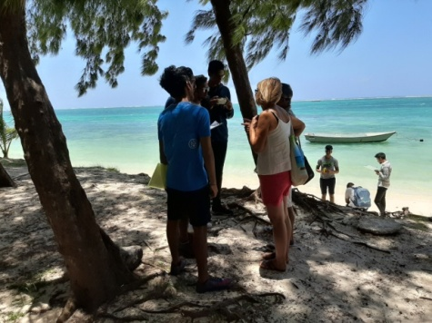
Interviewing tourists during survey
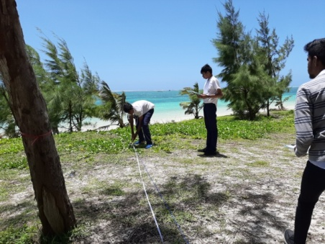
Measuring beach width from a reference object
2.3. Dr. Regis Chaperon SSS
The Flic en Flac beach, located on the west, was selected as it is the most popular and accessible beach. It also represents several interesting coastal features particularly in terms of sand erosion and accretion. The first indoor session took place on 05 February and 17 students of Grade 12 and 3 educators participated.
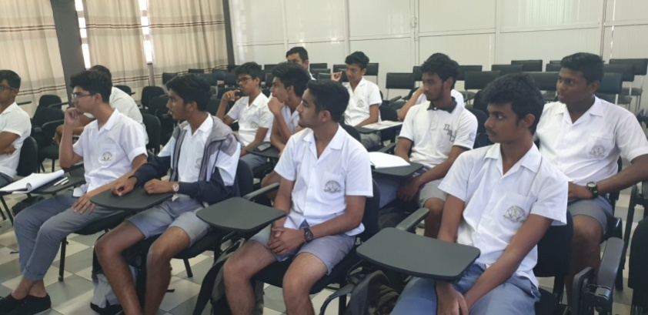
The first outdoor session was held on 12 February. Three reference objects were identified. These were:
- The end of the left concrete vertical wall of Villa Caroline Hotel when facing the hotel
- The end of the right concrete vertical wall of the Football ground when facing the football ground
- The left green wire fence of the Beach Authority Office.
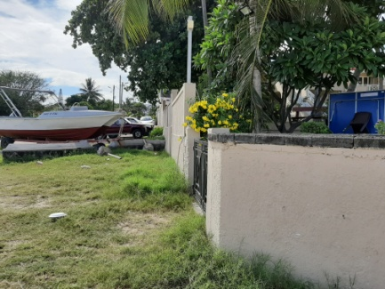
Wall of Villa Caroline Hotel
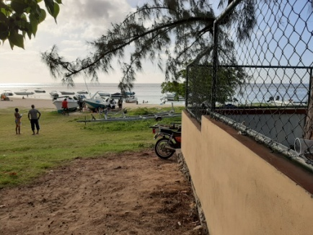
Wall of the football ground

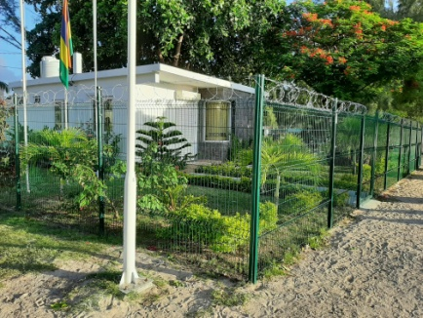
Right fence of Beach Authority
The second outdoor session on 18 March was cancelled due to bad weather.
3. Activities post-lockdown
When schools resumed on 1 July, restrictions imposed by the Authorities enabled only one outdoor field work to take place at SLTSSS at Belle Mare on 23 July. The Blue Bay public beach was closed due to the spread of oil spill from the MV Wakashio, which ran aground on 25 July off Pointe d' Esny threatening the Blue Bay national park. Access to the beach remained banned for a long period, precluding any outdoor activities. At DRCSSS, instruction from the Authorities was strictly followed and all outdoor activities at Flic en Flac were cancelled.
Nonetheless, several in-class activities at the three schools were organized to consolidate knowledge of students in data entry in the Database and prepare them for presentation of their findings. The Ministry of Education permitted only a school-wise closing ceremony, instead of one ceremony for the three schools as originally planned. This took place on 28 October at SLTSSS, 5 November at FBGSSS and 26 November at DRCSSS.
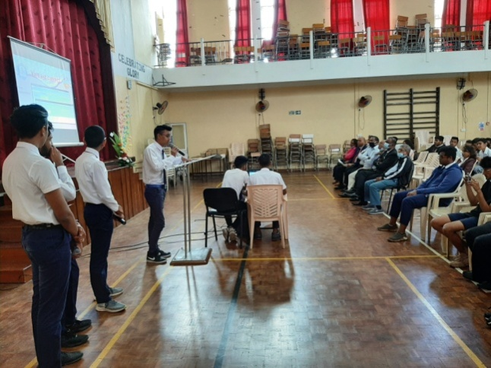
Students’ presentation at SLTSSS
Certificates of achievement were awarded to all participating students at the three schools.
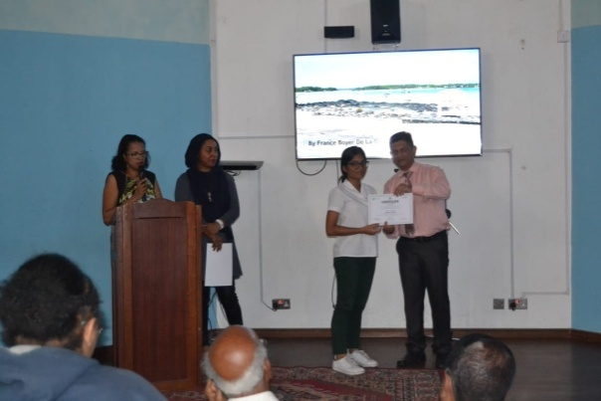Certificate award ceremony at FBGSSS
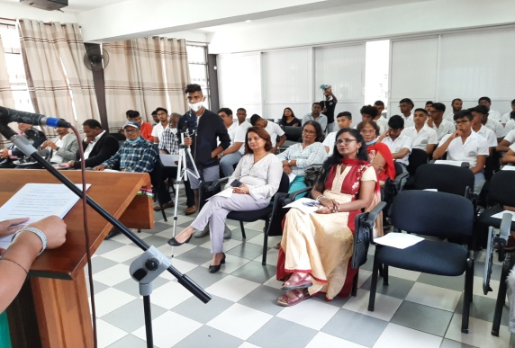
Audience at the closing ceremony at DRCSSS
4. Publicity given to sandwatch 2020
Wide publicity was given to sandwatch activities as from January 2020 at the very start of implementation. Besides the article in the sandwatch newsletter and ADD website in February 2020, an article appeared in the weekly English newspaper “News on Sunday” of 26 March 2020.
FBG SSS and DRC SSS also posted some photos of the closing ceremony on their respective Facebook site.
5. Concluding remarks
All students and Educators have appreciated the benefits of sandwatch to enhance sensitization on beach resources. The three schools have signified their intention to participate in the next sandwatch programme during the first term of the academic year in June 2021. Interest has also been shown to extend the programme with the participation of a school in the north. Rodrigues too could start implementing sandwatch this year. The Rodrigues Executive Council has already given its green light. ADD is prepared to take up the challenge and continue to promote sandwatch in the Republic of Mauritius.
6. Acknowledgements
ADD wishes to express its thanks to the Ministry of Education, Technical Education, Science and Technology, Ministry of Blue Economy, Marine Resources, Fisheries and Shipping; Currimjee Foundation for funding the programme, Rectors, Educators and Students of FBG SSS, SLT SSS and DRC SSS for their active engagement to ensure success of the programme. Last but not least, to ADD members for their involvement at all stages of preparation and implementation.
ADD acknowledges the specific attention and encouragement given to its activities in Mauritius by the Sandwatch Foundation and UNESCO.

