Sandwatch Mexico: schools ratify agreement and appoint first ambassador
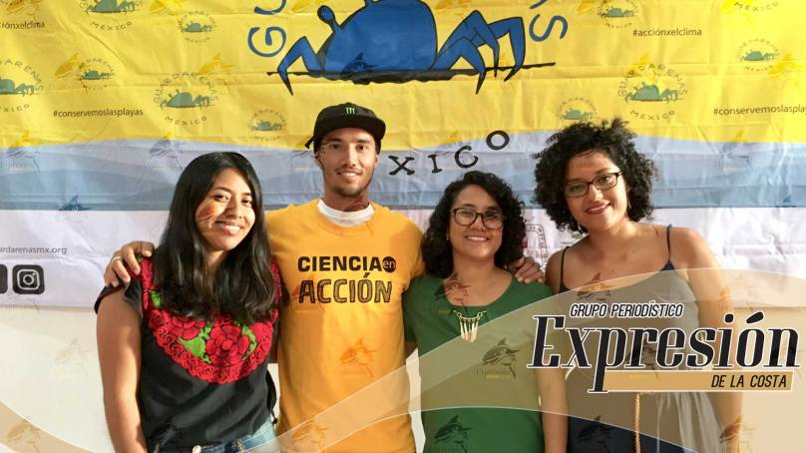

3 June 2017. Puerto Escondido, Oaxaca.- At the end of one year, the environmental education program and promoter of science in action, Guararenas Mexico, the pioneer in the country, confirms their commitment agreed with the directors of four schools in this city and appoints its first ambassador, Surfer Ángelo Lozano Corzo.
The following school year, 2017-2018, Sandwatch activities will continue with the students of the schools Juan Rulfo, Benjamín Bloom, Calmecac and Conalep, so they do not lose continuity.
"We will adjust the activities to the school year so that those who move to another grade do not lose the sequence of work that is being done every Saturday at the beach in Bacocho and Coral. With the signing of each agreement, we announce that we will continue Sandwatch for one more year" .
Seeking support: The participation of four teachers as well as the students has been voluntary, as well as the Guardarenas team: Carolina Luna and the marine biologists Montserrat López, María de Jesús Trejo and Edith Silva of the UMAR Puerto Ángel, who have started a campaign to raise funds for the equipment and maintaining Sandwatch activities.
"Gabriel Sánchez created a promotional video to share on social networks. We want to make Sandwatch sustainable and to motivate people who support us with donations “in kind” and monetary. We know that Oaxaca and its coast is famous for international tourism, and we hope that donors and companies will identify with the program and adopt it, "said Escalona.
Guardarenas Mexico have their own website (www.guardarenasmx.org) and will have ambassadors, such as artists and sports heros to promote it. The Buenos Airean surfer Angelo Lozano is the first ambassador.
"Encouraging students to continue doing research and take action against climate change that is resulting from global warming, and generating awareness among the new generations, about the importance of taking care of beaches and their ecosystems is important for Puerto Escondido and the ecology ", he said.
The team hopes is to replicate Sandwatch in other beaches of Oaxaca, so far they have had talks with Pochutla and the city of Huatulco.

