Story for the The Sandwatch Magazie
Ibo island, located in Quirimbas National Park (UNESCO World Biosphere Reserve, map bellow), is the oldest and the most important insular settlement area in the region, surrounded by critical and important ecosystem, critical marine and coast habitats in the region. Ibo island urban area preserve its unique traditional, cultural, and natural heritages.
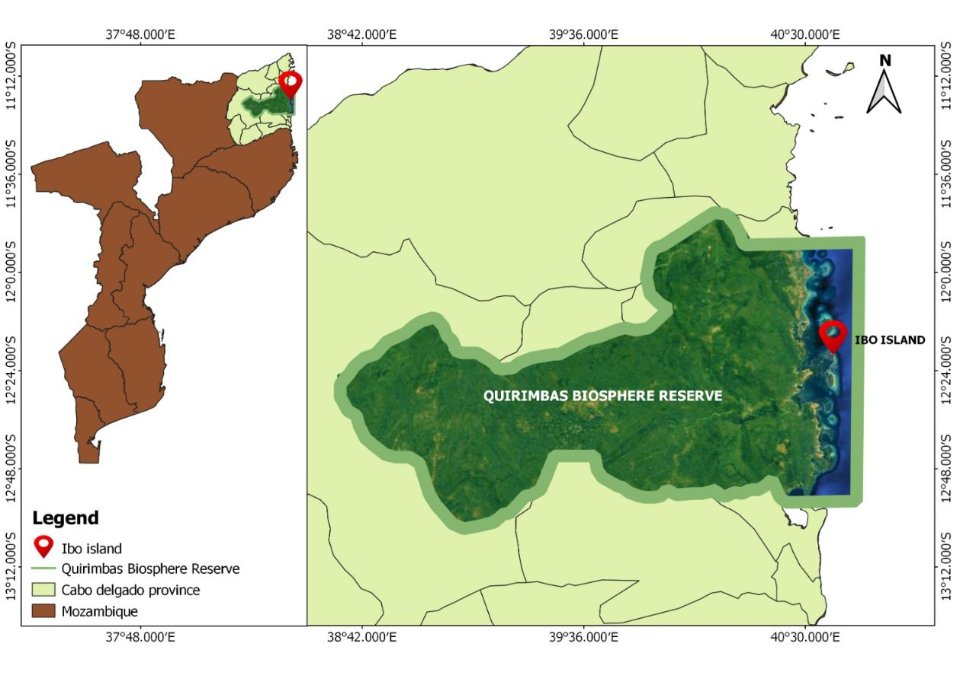
ASMOG, local CBO established by local community member, mostly youth, has engaged local communities to adopt best practices to preserve critical habits, sustainable use of natural resources and waste management against pollution by plastics.
During the last 3 months ASMG has engaged local education authorities, government, and communities, for the establishment of environment clubs at local school. Now, we count with a total 60 student and teachers, that have been involved in sensitization activities, hands on practical activities for the awareness to learn and adoption of practice to preserve the environment and heritage areas. The students have been participated in the cleanup campaign, recycling workshops and dissemination of experience gained to other kids and communities’ members.
The other items collected from the clean up activities, are used to produce ecobricks, using hand simple techniques for the confinement o plastic waste, that will be applied to build to introduce new methods of model house construction in Ibo island.
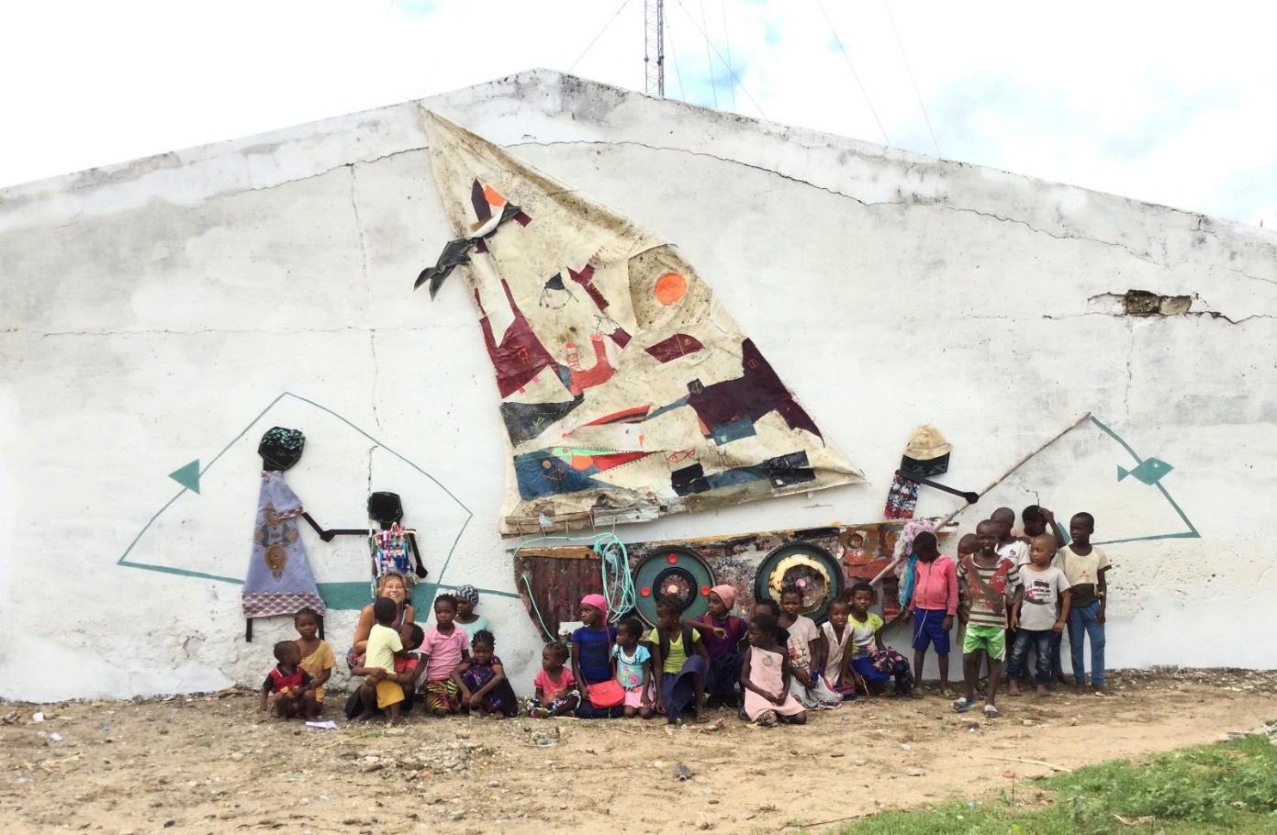
Artistic mural wall built by ASMOG, using recycled material, collected during the cleaning up activities with the involvement of students from the environmental club

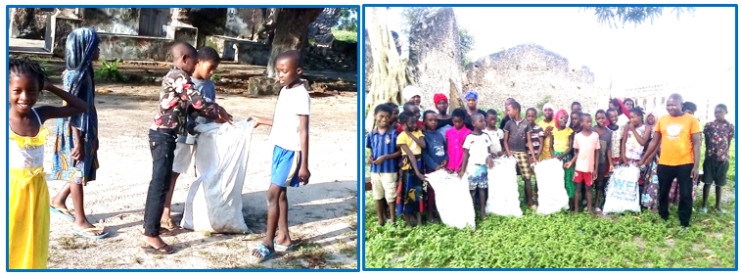
Cleaning campaign (selective collection of solid waste). Date: 18-25.02.2023

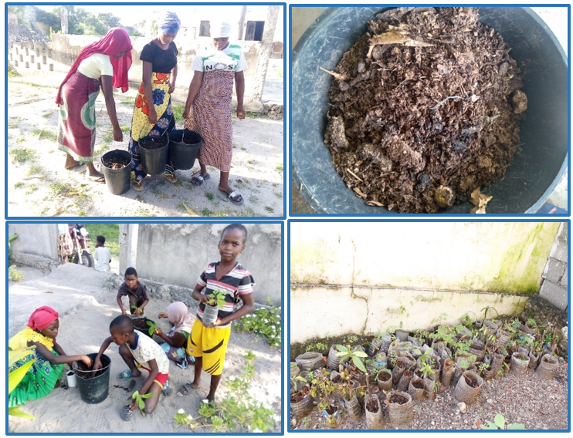
Production of plant seedlings with students from environmental clubs. Date: 18.02.2023

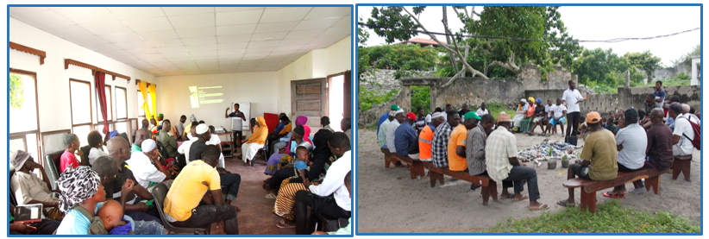
Community participation in environmental activities. Date: 03-04.03.2023

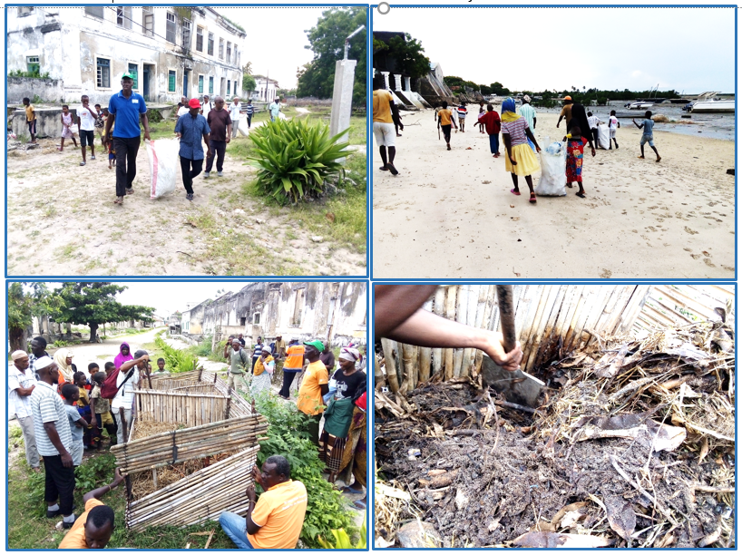
Community participation in cleaning campaigns and composting. Date: 03-04.03.2023

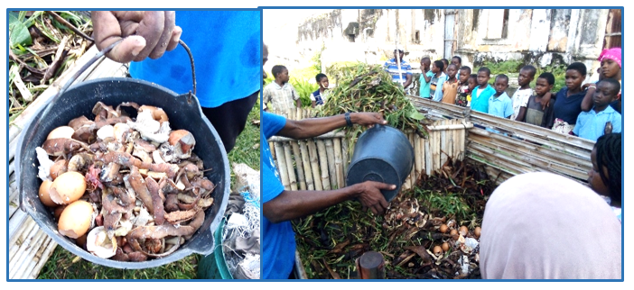
Induction of students from environmental clubs into the community compost bin. Date:03-04.03.2023
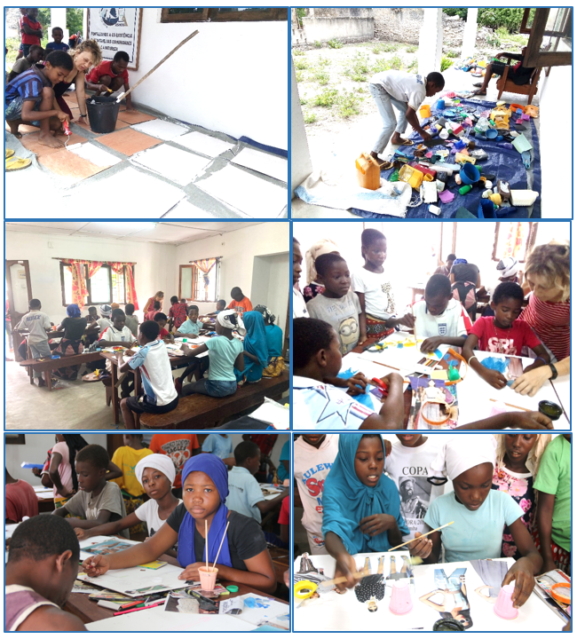
Workshop of artistic recycling. Date: 25.03.2023

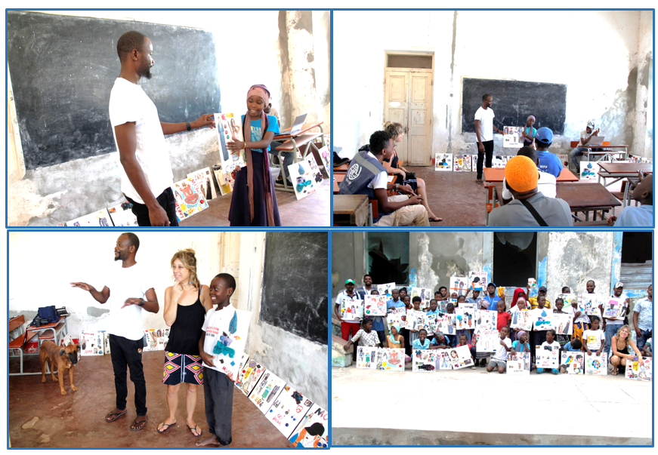
Exhibition of artistic paintings at Eduardo Chivambo Mondlane Primary School. Date: 08.04.2023

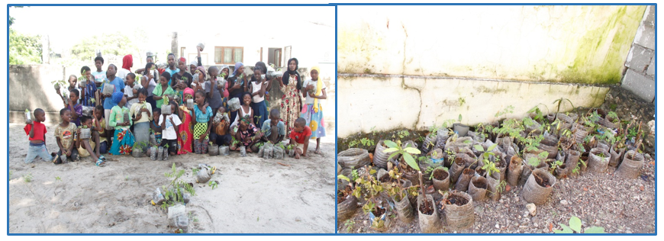
The progress of the seedling production activity. Date:15.04.2023

